VICTORIA MEGATOUR 2023 19th-30th November (12 days)

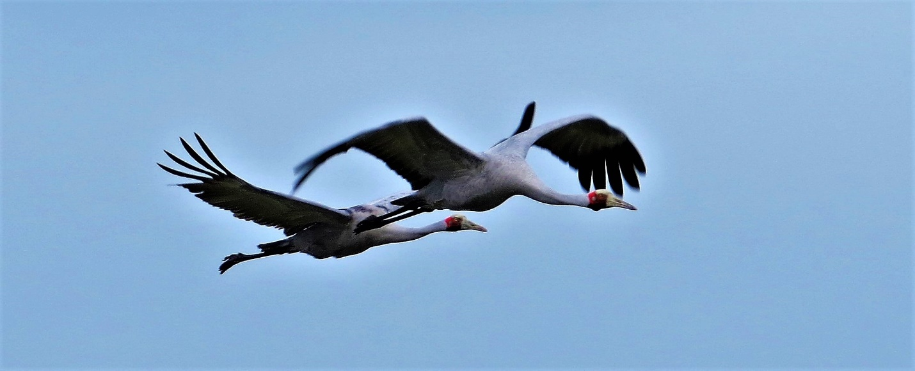

Tour Information: Tour length: 12 days

Departs: from Melbourne on the morning of Sunday 19th November 2023 and concludes in Melbourne on the evening of Thursday 30th November 2023

Leader: Simon Starr and local guides as required.

Group Size: Minimum three participants, maximum seven plus guide

Cost: With 3 to 5 participants - Aus $6,330-00 per person (single room)

With 6 or 7 participants - Aus $5,540-00 per person (single room)

Note: Double/twin share arrangement reduces individual cost by $480 per person

What to bring: Binoculars, hat, sunscreen, insect repellent, and a personal drinking bottle.

What to wear: Come prepared for all weather. Recommended are long lightweight pants, comfortable and sturdy walking shoes/boots, and a lightweight long-sleeved shirt. Wind proof and warm over clothes can then be put on as extra when required.

Physical Requirements: This tour involves some walking in a variety of terrains. A moderate level of fitness is necessary. The days will start early and highway travel time is normally 3 hours maximum each day, except for day 4 (the drive over the mountains) which is mostly a travel day with shorter birding stops. Your guide will be available for birding dawn until dusk, with spotlighting opportunities on some evenings also (see detailed itinerary).

Day 1: West Gippsland
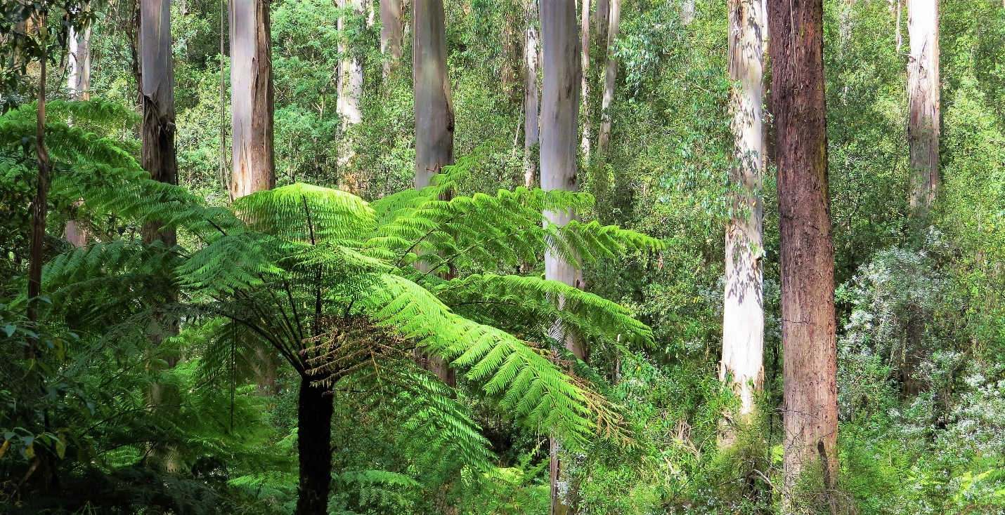
Departing Melbourne pre rush hour we shall spend a little time in the eastern suburbs where perhaps a roosting Owl or Frogmouth may be found as well as a range of Parrots, bush birds and waterbirds. Once clear of the city we will travel out into the West Gippsland region and sample some of the extensive forested areas.
A selection of forest birds will be looked for, such as White-throated and Red-browed Treecreeper, Eastern Yellow and Rose Robin, Grey and Rufous Fantail, Satin Bowerbird, Lewin’s and Crescent Honeyeater, Yellow-tailed Black and Gang-gang Cockatoo, Crimson Rosella and Australian King-parrot.
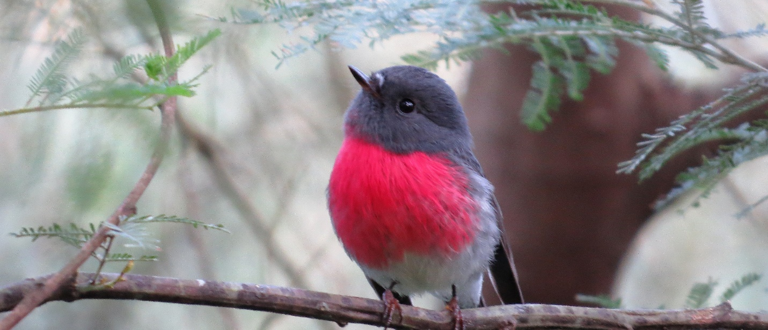
Through the middle of the day we will visit a higher altitude area where cooler and damper conditions support a lush green environment protected from fire and full of tree ferns and patches of cool temperate rainforest. Additional species possible here can include Pilotbird, Olive Whistler, Bassian Thrush, Flame Robin, Pink Robin and Superb Lyrebird
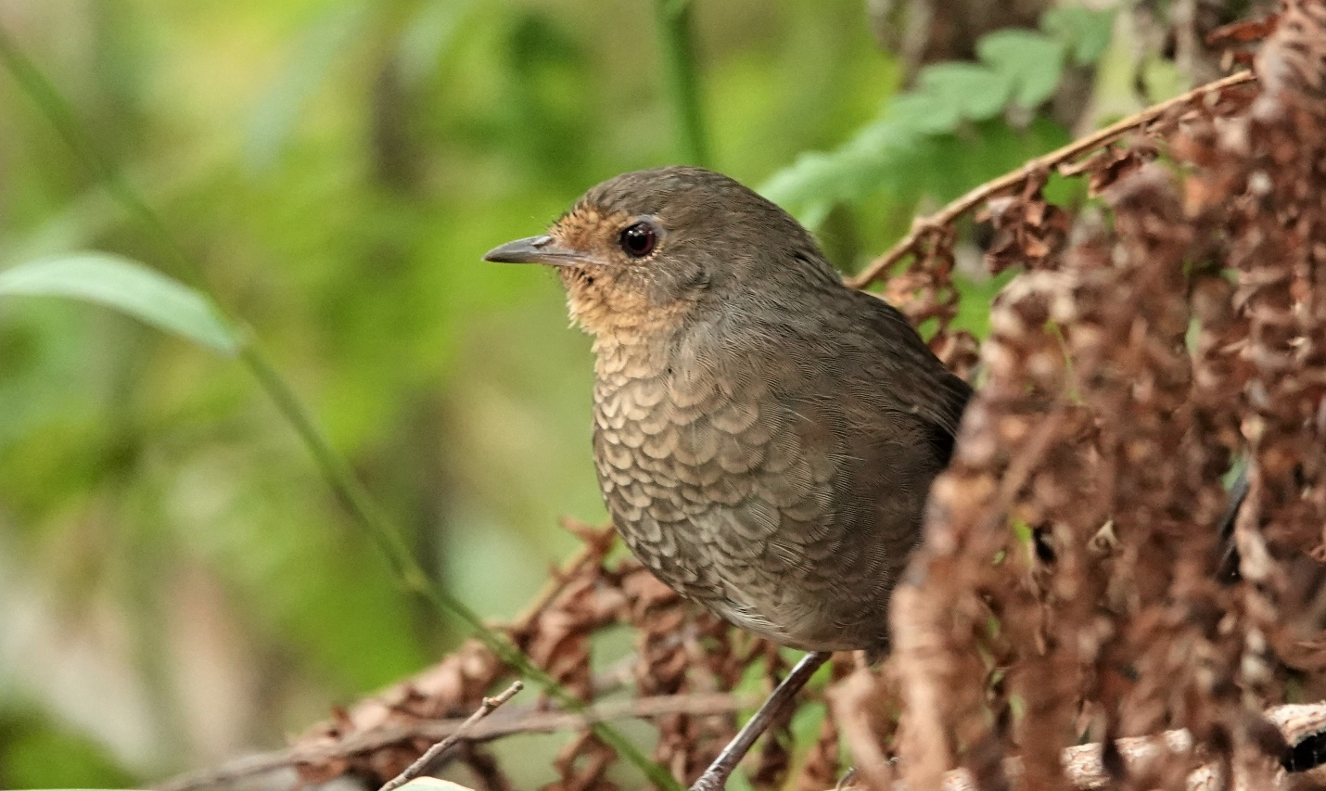
Later in the day we will continue east reaching the Gippsland lakes district with some time to drop into some of the many wetlands. Depending on water levels we may find Latham’s Snipe, perhaps a Rail or Crake will show, Sea-Eagle and Swamp Harrier, plus nesting Spoonbills and Egrets. In some years the rare endemic Freckled Duck is present.

Days 2 and 3 : East Gippsland
Over these two days we will be exploring the wide variety of birding sites in the East Gippsland region near the towns of Bairnsdale, Lakes Entrance, Orbost and Marlo. This wonderfully nature rich region still maintains around 80 percent native forest cover.
In the foothills and coastal regions, habitats include both dry and wet sclerophyll forest, warm temperate rainforest gullies, open pastoral land, coastal banksia forests, dunes and beaches, heathlands, wetlands and rocky coastal capes.

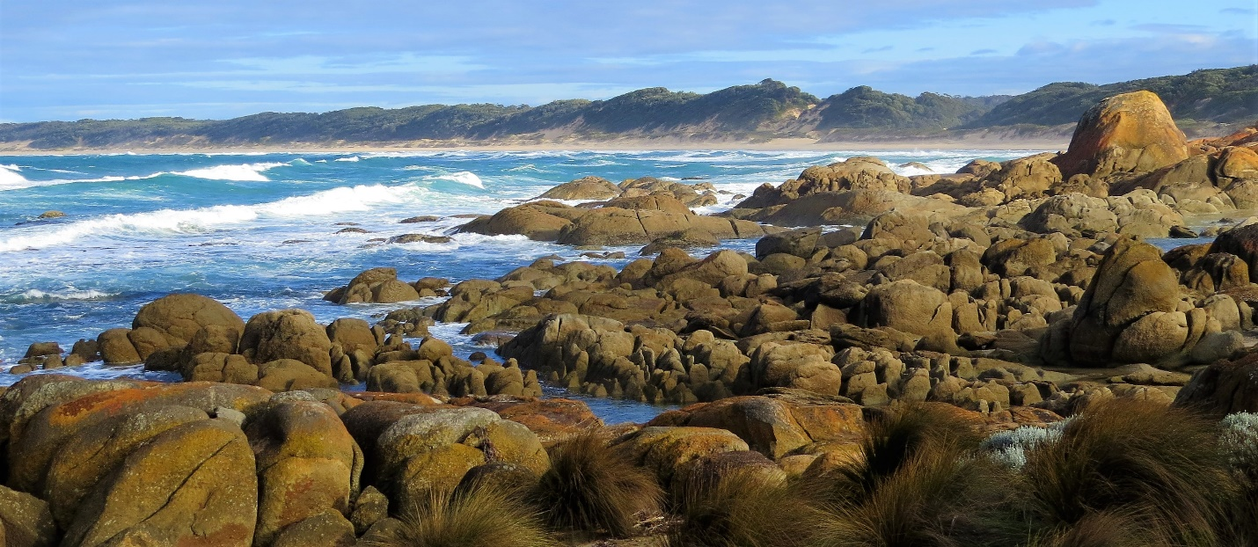
Just some of the key species to be searched for will include Black-faced Cormorant, Hooded Plover, Pacific Gull, Albatross, Shearwaters and Jaegers if wind conditions are suitable, White-bellied Sea-Eagle, Satin Bowerbird, Azure Kingfisher, Wonga Pigeon, White-headed Pigeon, Gang-gang Cockatoo, Glossy Black Cockatoo, Brown Gerygone, Rose Robin, Turquoise Parrot, Eastern Ground Parrot, Little Lorikeet, Superb Lyrebird, Brush Cuckoo, Crested Shrike-tit, Rufous Fantail, Pilotbird, Black-faced Monarch, Leaden Flycatcher, Bassian Thrush, Spotted Quail-thrush Southern Emu-wren, Crescent Honeyeater, Lewin’s Honeyeater, Scarlet Honeyeater, Little Wattlebird, Cicadabird,.plus waders and terns at various estuaries.
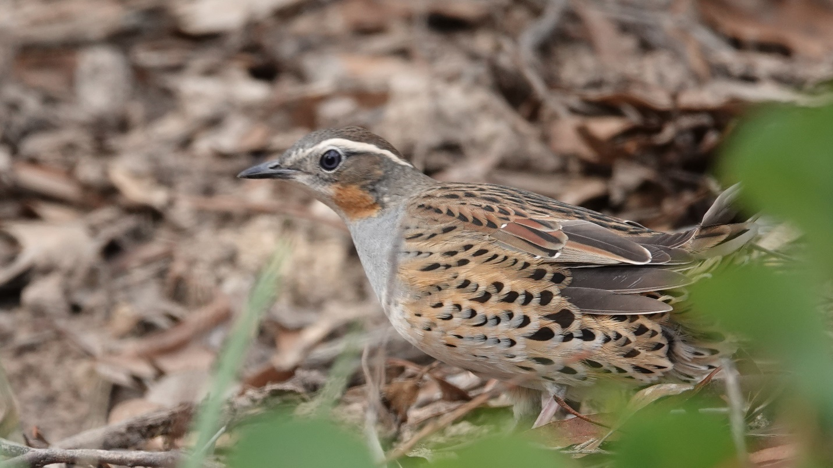

We will also have the opportunity for some spotlighting adventures where we will wait at dusk for sightings of White-throated Nightjar and have a chance to encounter any of the larger forest Owls (Sooty, Masked, Powerful). Other possibilities include Tawny Frogmouth, Southern Boobook, Australian Owlet-nightjar and a wide range of nocturnal mammals. These sessions are sure to be exciting even if a little unpredictable.
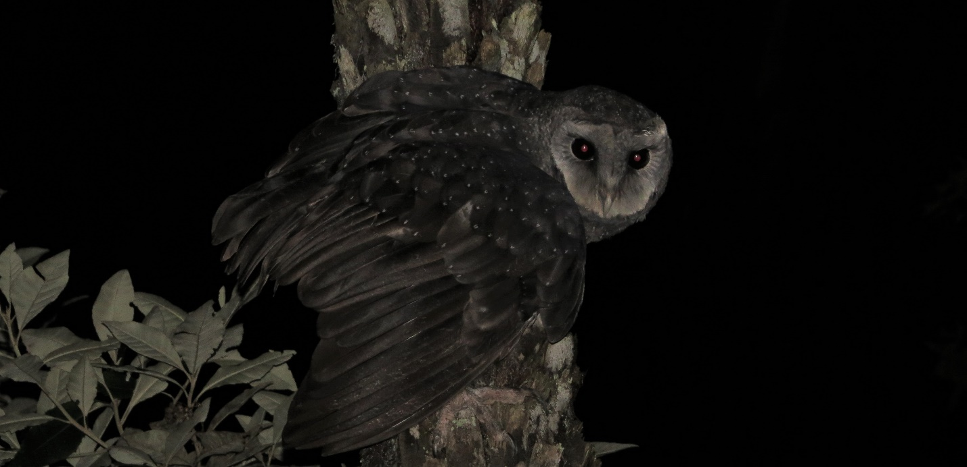

Day 4: East Gippsland to North-east Victoria 22nd November
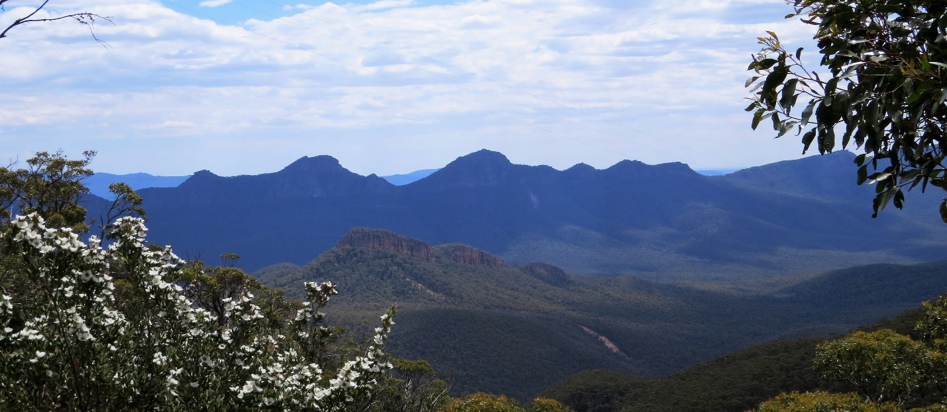

Today is a travel day with short birding stops along the way. We will make the fairly long drive north up and over the high mountains and snow fields of the Great Dividing Range. We can enjoy the dramatic scenery and even in November there is often a little snow left on the south facing higher slopes. On the way we will be likely to encounter a variety of Raptors, Parrots, Currawongs, Thornbills and Robins including the stunning Flame Robin which breeds in the alpine high country in summer. Random sightings have included Satin Flycatcher, Olive Whistler and Spotted Quail-thrush, each drive is a little different
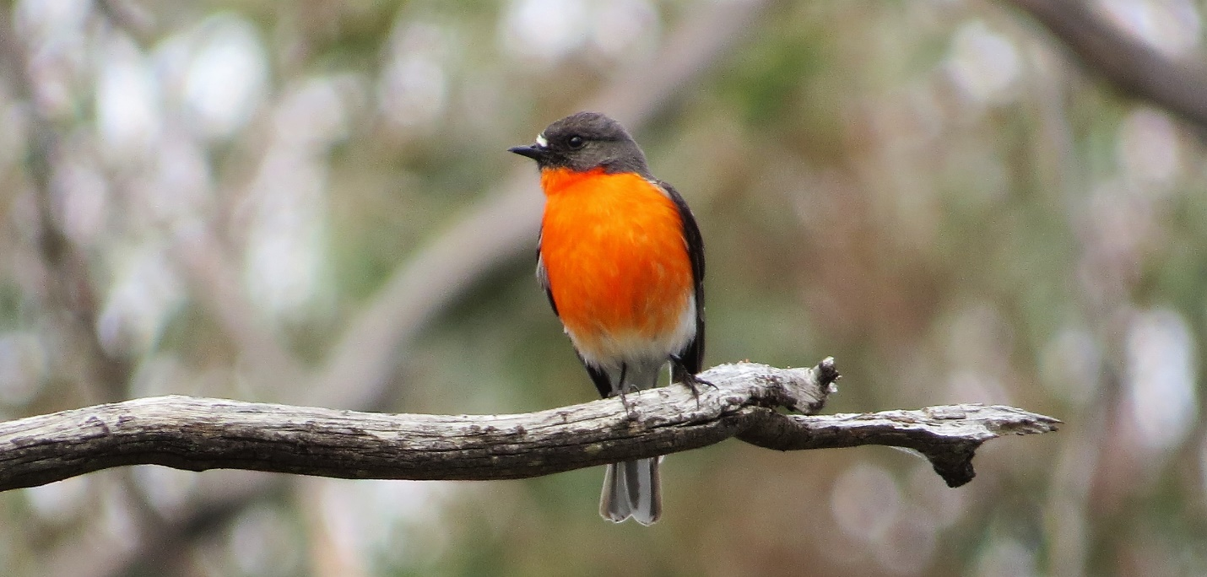
Later in the day we will have some late afternoon birding time in the drier more open woodlands of north-eastern Victoria where a whole new range of birds awaits us, and we will undoubtedly be rapidly adding to our trip list

Day 5: North-east Victoria - 23rd November
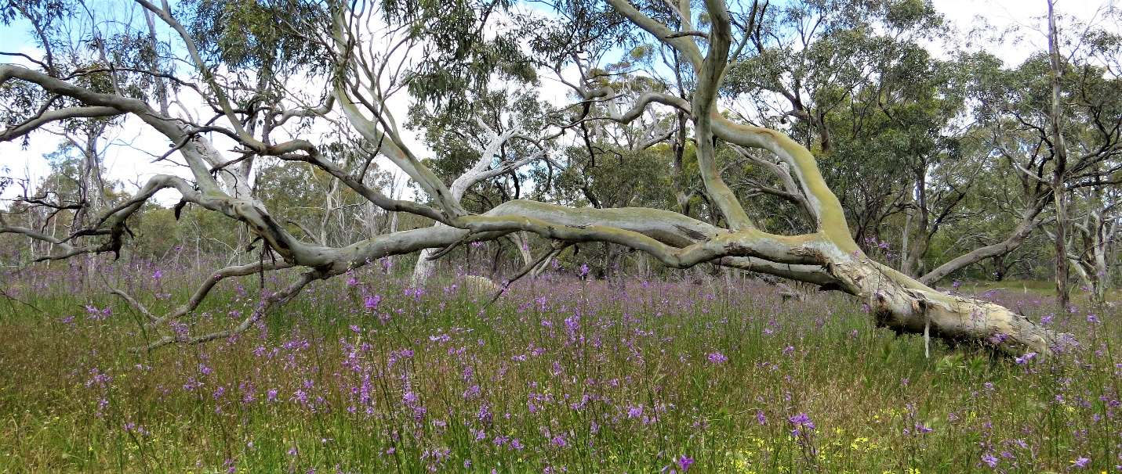
After a big day’s travelling yesterday, today’s agenda is relaxed birding in the forests, floodplains and wetlands of North-east VIctoria concentrating on two excellent National Parks, Warby-Ovens and Chiltern-Mt Pilot.
Flowering trees attract Honeyeaters and Lorikeets whilst the open shrubby and grassy understory of these woodlands are good for various Thornbills, Robins and the Speckled Warbler.
These quality woodlands will yield many species including Orioles, Cuckoo-Shrikes, Shrike-tits and Friarbirds. The birding will be lively, and the rare and beautiful Turquoise Parrot will be an important target species.as well as a wide range of other bushland gems such as Painted Honeyeater, Painted Button-quail, Diamond Firetail, Red-capped Robin, White-throated Gerygone, Western Gerygone, Restless Flycatcher and Mistletoebird
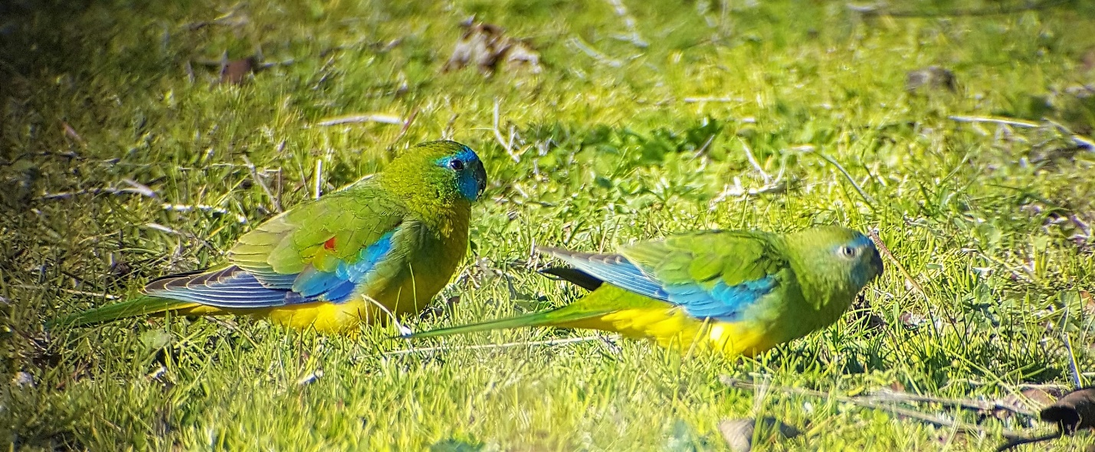
A little spotlighting this evening is bound to be interesting with a variety of nocturnal birds and animals possible in the River Red Gum floodplains of the area.

Day 6: North-east Victoria to the NSW Riverina – 24th November
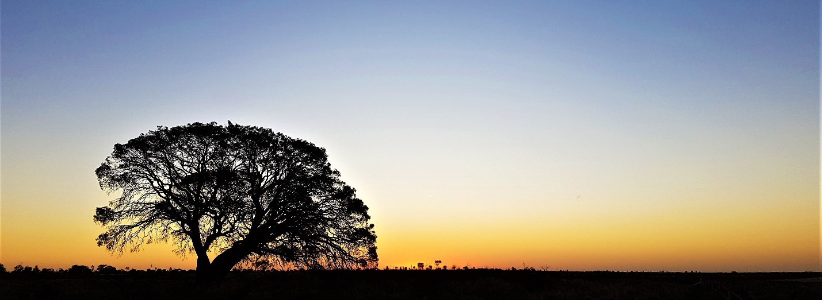
Today is a big day in two parts. In the morning we will wind our way north and west through the flatter and more fertile agricultural regions of the Murray Darling basin. A smattering of woodlands and wetlands will add to the species list as we traverse various rivers and their associated extensive River Red Gum forests
We will keep our eye out for a number of bird species best found in this north-eastern part of Victoria including Plumed Whistling-duck, Azure Kingfisher, Dollarbird, Superb Parrot, Grey-crowned Babbler, Little and Noisy Friarbirds, plus a variety of waterbirds. Depending on the season some wetlands may have colonial breeding colonies, and we have seen both Australasian and Black-backed Bittern in some years
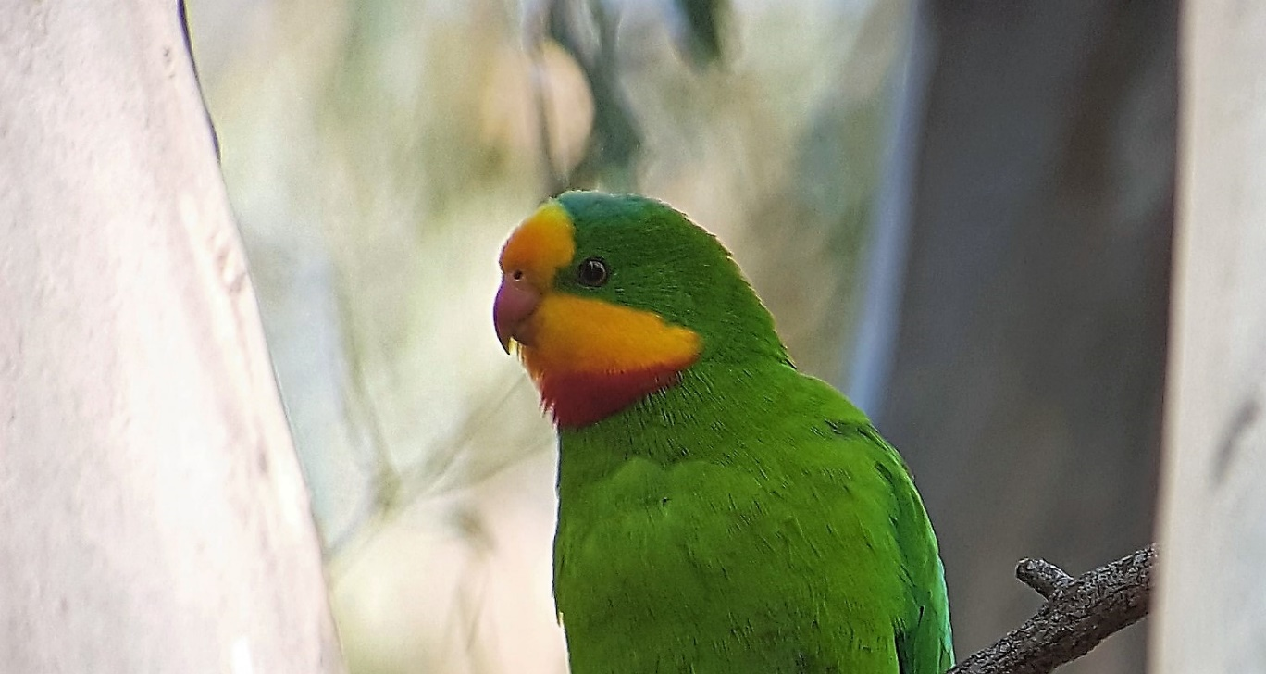
Mid afternoon we will arrive in Deniliquin, in southern NSW where we will have a break before we will head out again onto the Hay Plain to the north of town, This is a vast flat and treeless area which is home to some unique wildlife. Birding along the way we will encounter many new species for the trip, such as Blue-bonnets and White-winged Fairy-wrens as well as the iconic Red Kangaroo. Other sightings in the past have included Orange Chat, Painted Honeyeater, Striped Honeyeater, Grey-crowned Babbler and Black Honeyeater, each year varies. At dusk we will have a picnic dinner out in the wilds after which we will embark on a spotlighting adventure in search the critically endangered Plains-wanderer. These open grasslands hold other highlights too, and depending on the climatic conditions Inland Dotterel, Little Button-quail, Stubble Quail, and Australian Pratincole are all possibilities.
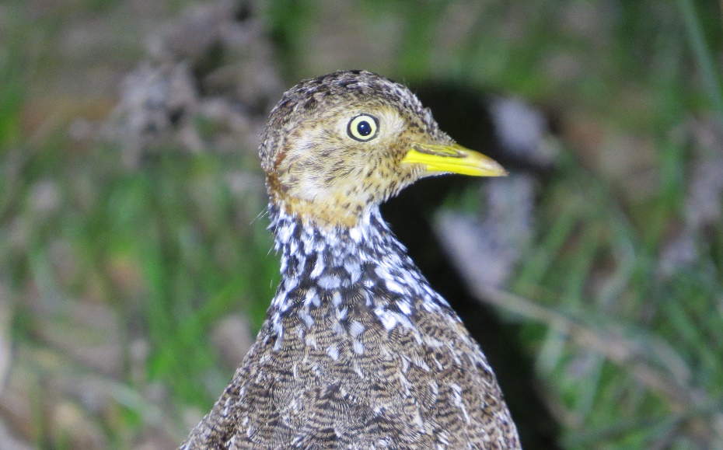
And there is a more, Barn Owls can be quite common here, Owlet-Nightjar is often seen, and the cute Fat-tailed Dunnart is a small marsupial often found also.
Day 7 Deniliquin to the Mallee (North-west Vic)
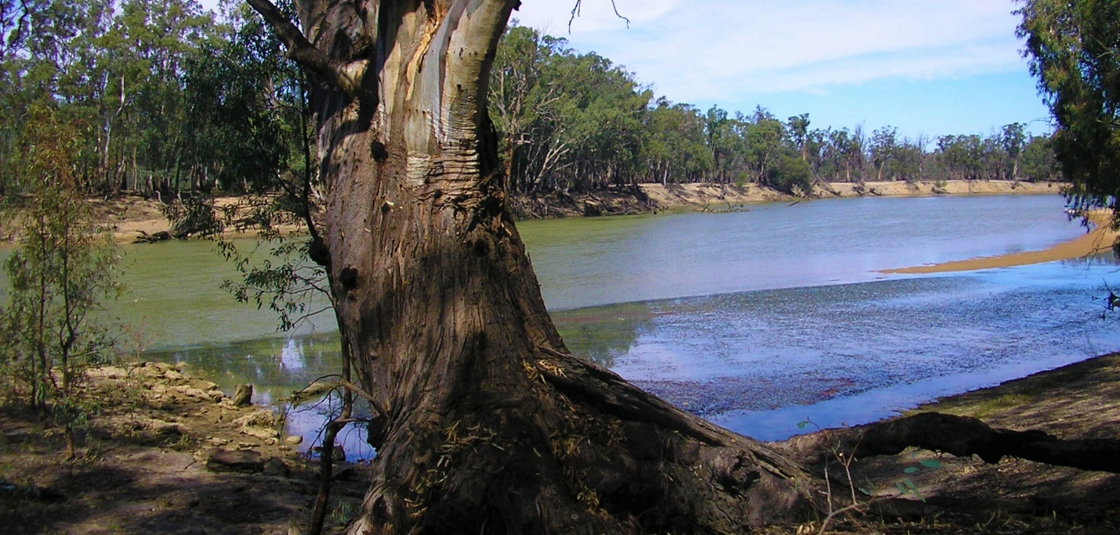
After a massive day yesterday, today will start a little later and include a morning walk near town at a lively site which will produce a wide range of woodland birds and parrots nesting in the old Red Gums such as Superb Parrot and Yellow Rosella.
Today’s drive will take us all the way from the plains, wetlands and red gum forests of the riverina to the semi-arid mallee region of north-western Victoria.
Driving back into Victoria we will stop at a wetland or two in the Kerang region depending on seasonal conditions. Environmental watering creates perfect habitat for a wide variety of waterbirds. Freshwater and saline wetlands increase the diversity and combined with a selection of remnant mallee woodlands, black box lined waterways and open grassland areas a healthy species total can be expected for the day. Some birds to look out for will include White-winged Fairy-wrens and equally dazzling Orange Chat, the rare Black Honeyeater and Blue Bonnets and Cockatiels may start to appear along roadsides. Raptors will feature strongly today with up to 12 species possible in the area.
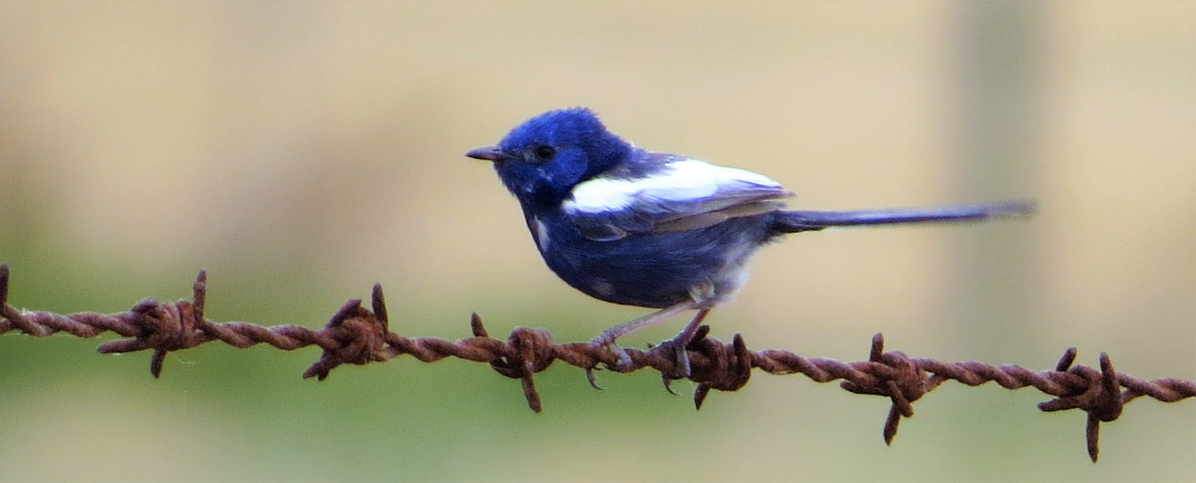
Late in the day after driving through “endless” wheat fields into the extensive semi-arid mallee country of north-west Victoria, short stops will see us connect with a few of this region’s special birds including some stunning Parrots, before we have dinner and an earlier night ready for an early start tomorrow.
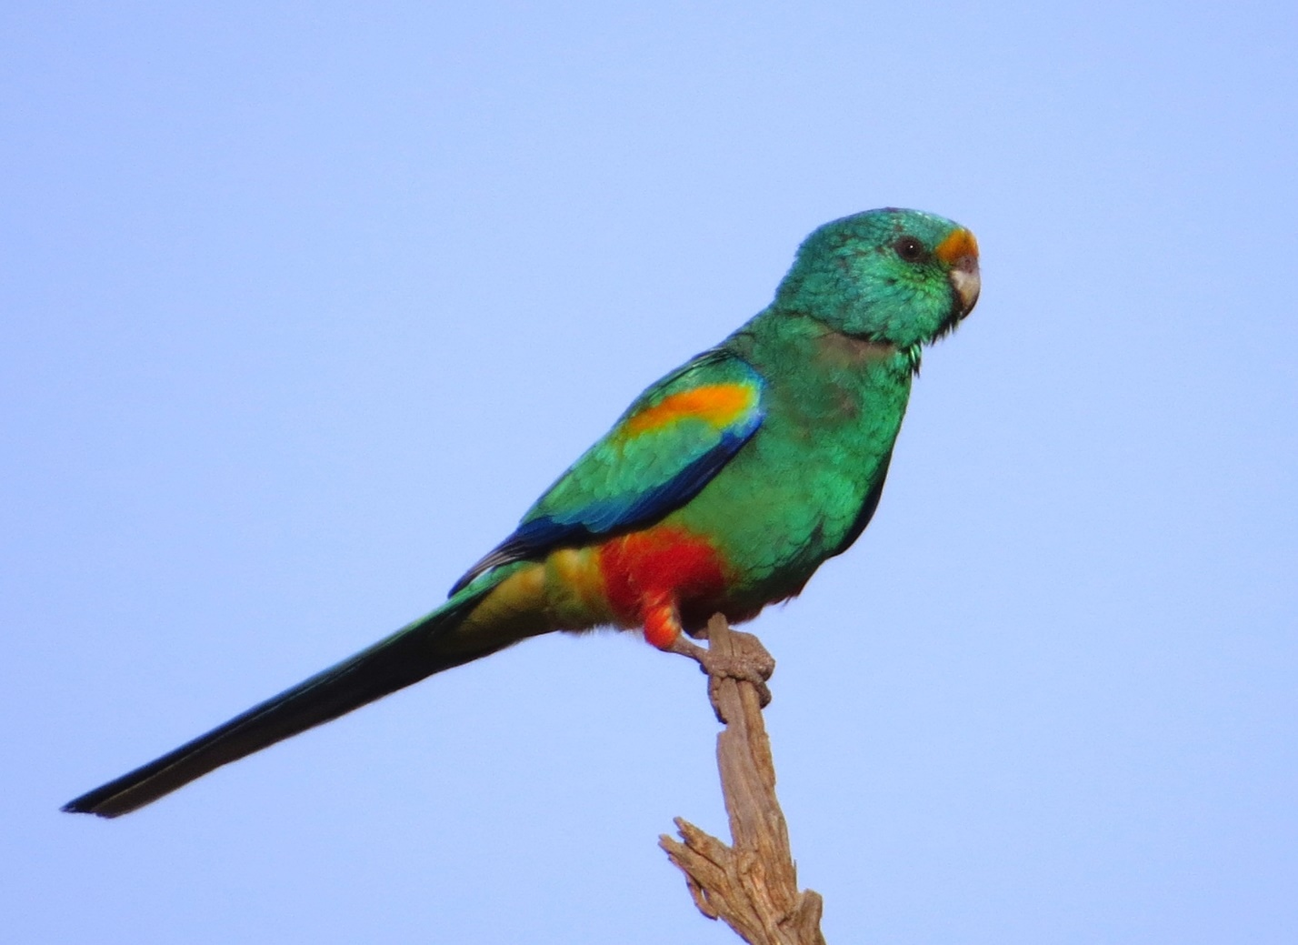

Days 8 and 9 The Mallee
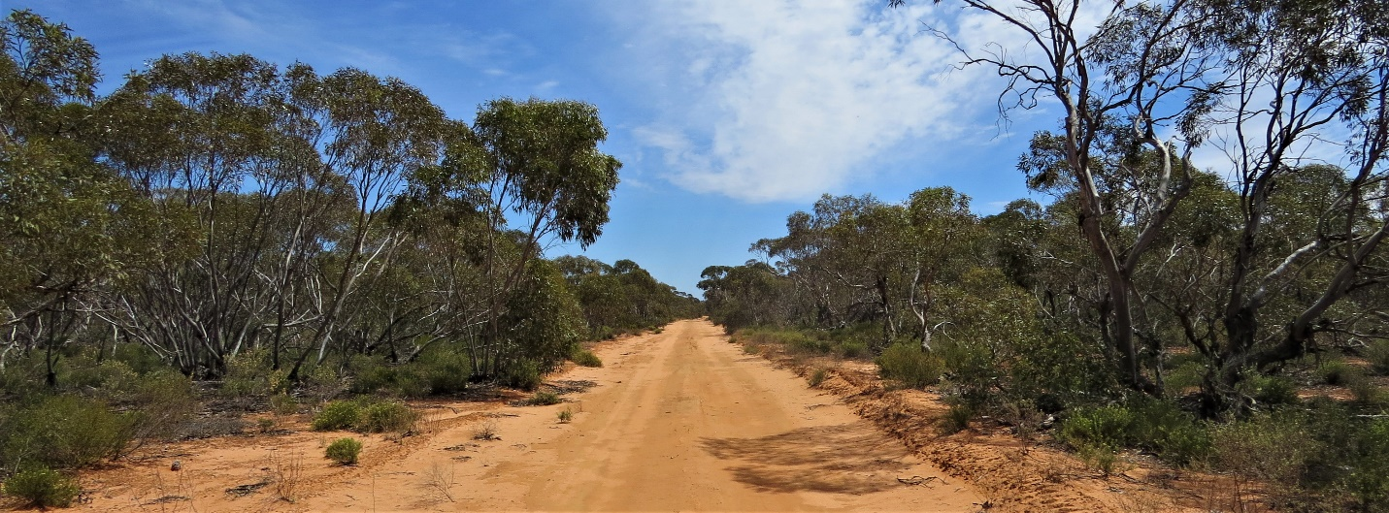
Over the next two days we can take our time to explore the vast National Parks in north-western Victoria . We will be targeting some of the rare and secretive birds of the region such as Mallee Emu-wren, Striated Grasswren, Malleefowl and Chestnut Quail-thrush, and along the way we will no doubt connect with many other dry country woodland species unlikely to be seen elsewhere during the tour. Birding time in quiet, remote locations where we can adjust to the pace of the outback. The great diversity of colourful parrots will brighten the landscape. Mulga Parrot, Australian Ringneck, Regent Parrot, Blue Bonnet, Yellow Rosella, Red-rumped Parrot, Pink Cockatoo and Little Corella may all be seen.
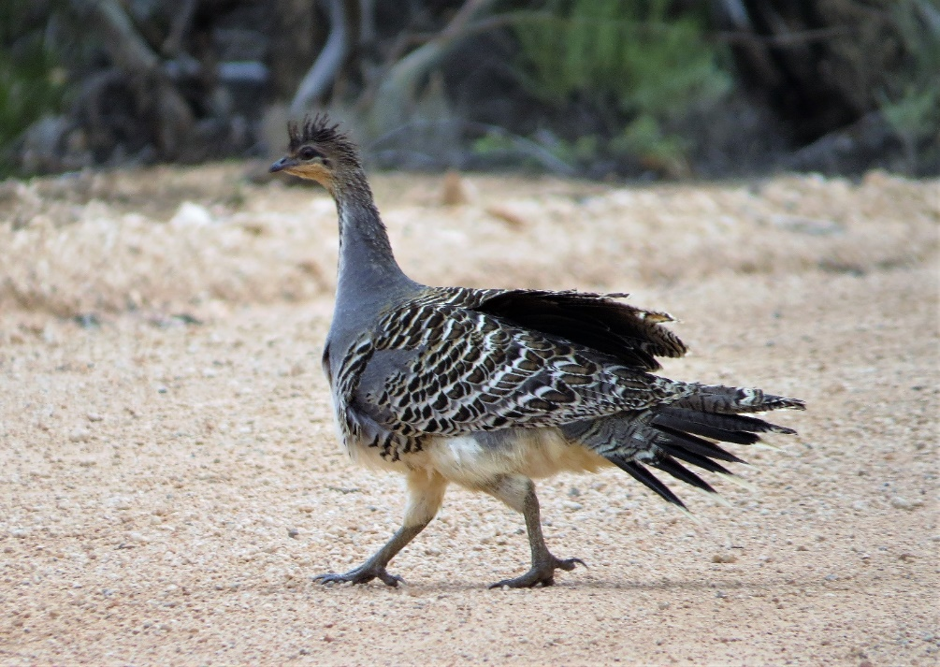
And of course one of the iconic species of the region is the Malleefowl. Past tours have nearly always located this tricky customer. Other birds on the agenda include Gilberts Whistler, White-browed Treecreeper, Striped Honeyeater, Crested Bellbird, Splendid Fairy-wren, Purple-backed Fairy-wren, Southern Scrub-robin, Australian Owlet-nightjar, Chestnut-crowned Babbler to name a few With luck we may also see more of the Red Kangaroo, Australia’s largest marsupial amongst the commoner Western Greys. Emus should also be encountered to complete the “megafauna” in this wild landscape.
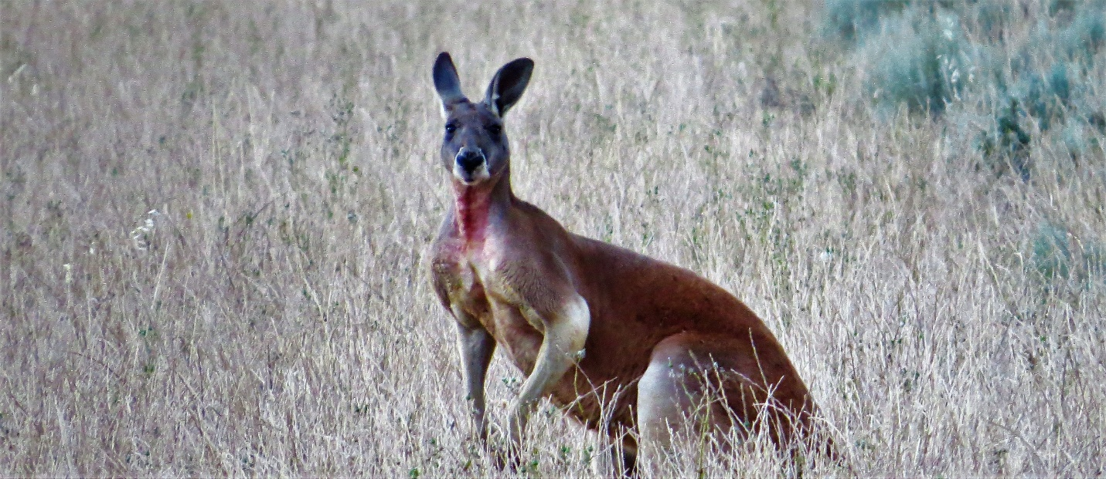
As well as the “mallee” habitat, this region supports areas of Cypress Pine woodlands, home to Pink Cockatoos and White-browed Treecreepers amongst others.
On at least one of our evenings in this region we will have the option to stake out a site for Spotted Nightjars at dusk, a must when visiting this region. The end of Day 10 will have us back in Central Victoria ready for the drive to the coast
Day 10 Central Victoria to SURF COAST
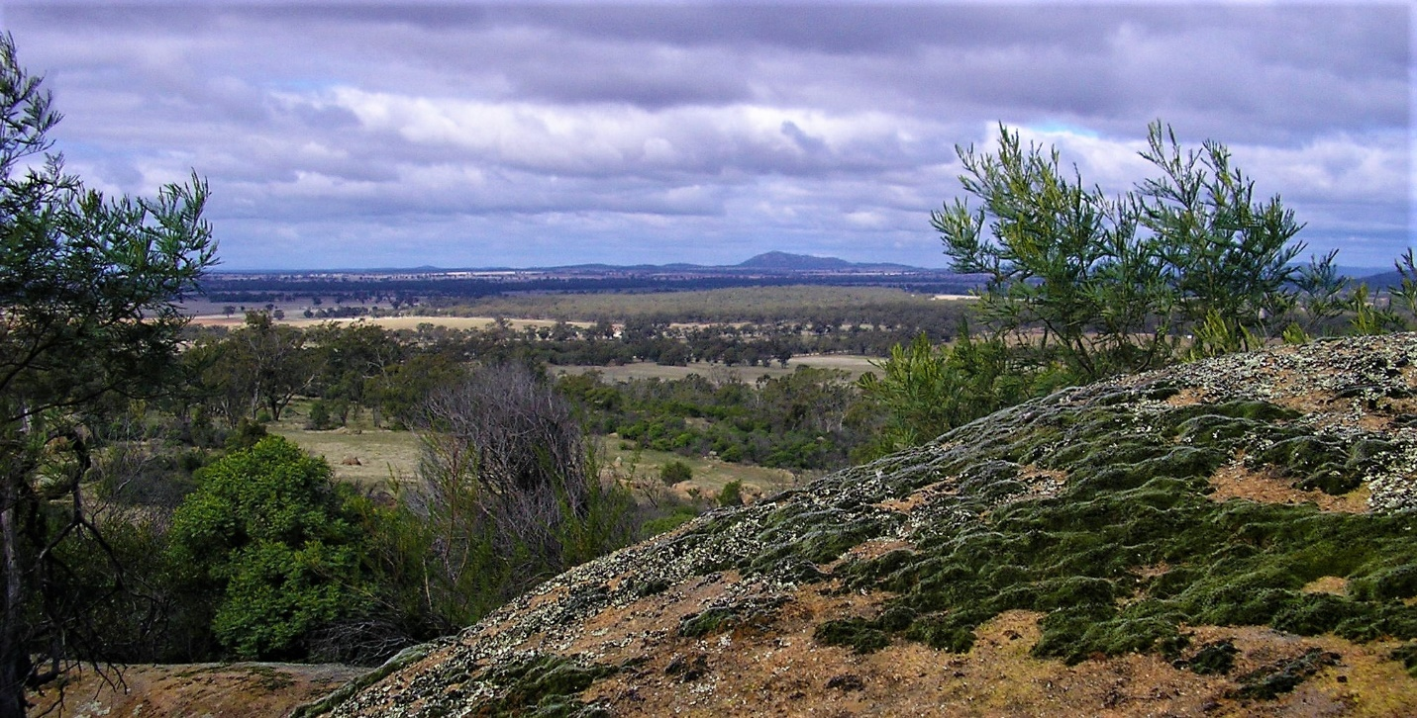
This morning we will hit the road heading south and take the scenic route through some of Central VIctoria’s mallee and box-ironbark forests. Some species we can look for that may be new for the trip include Tawny-crowned Honeyeater, Brush Bronzewing, Gilberts Whistler, Painted Honeyeater and Shy Heathwren..
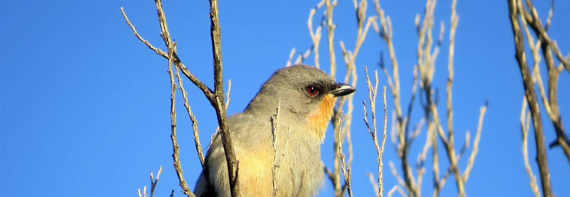
As we head south over the Great Dviding range and start to descend down to the coast, we can stop at some wetlands along the way given current conditions.
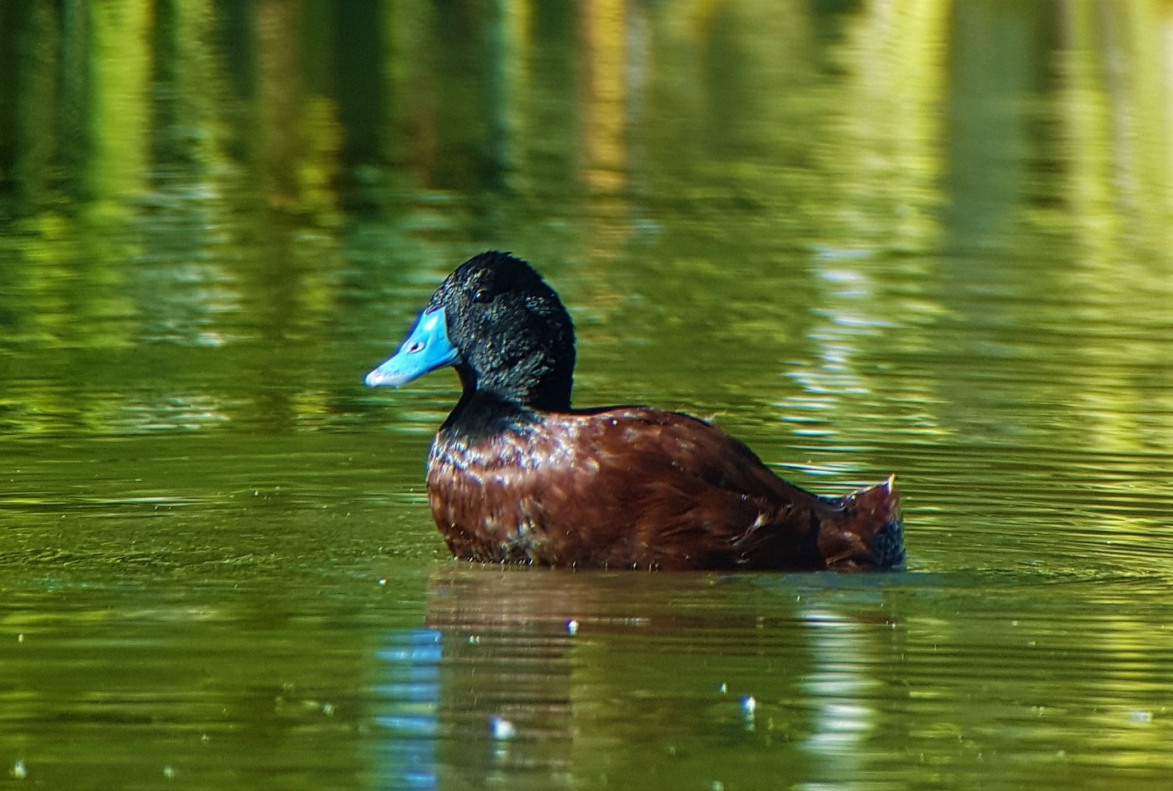
Forested areas south of the divide hold some cryptic skulkers such as Spotted Quail-thrush and Chestnut-rumped Heathwren. And down on port Phillip Bay some endemic waterbirds such as Cape Barren Goose and Banded Stilt could be picked up along the way.
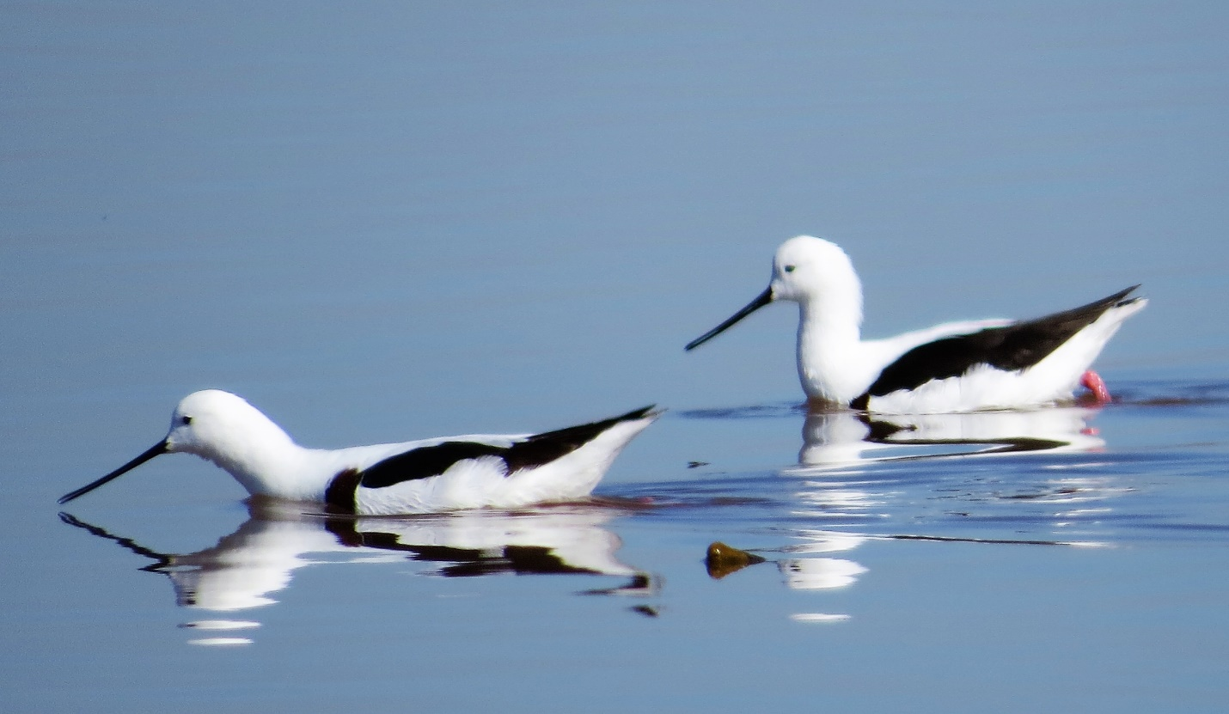
Tonight we stay down on the Surf Coast, ready for an exciting day tomorrow birding the scenic Great Ocean road

Day 11 Surf Coast and the Otways
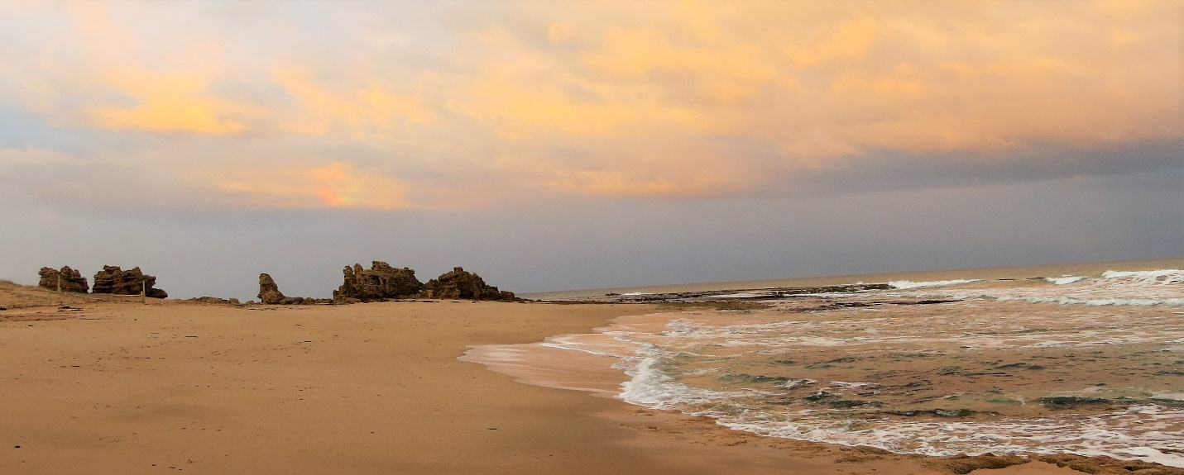
The stunning coastline of the Great Ocean road will greet us this morning, and early morning is the best time to catch a sight of the local endemic Rufous Bristlebird.
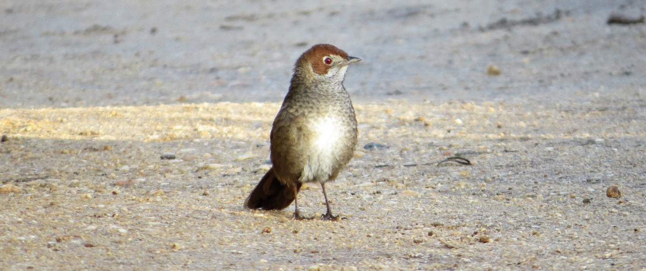
Gazing out to sea should give us some sightings of Australasian Gannet, Greater Crested Tern Short-tailed Shearwaters and Shy Albatross if the wind is up, whilst the threatened Hooded Plover frequents the beaches here.
Much of the day will be spent exploring the coastal heathlands and wet eucalypt forest of the region. Target birds will include the tiny Southern Emu-wren, Gang-gang Cockatoo, Yellow-tailed Black-cockatoo, Australian King-parrot, Lewin’s Rail, Satin Bowerbird, Blue-winged Parrot, Crescent Honeyeater, Scarlet and Flame Robins, Striated Fieldwren, Bassian Thrush, Olive Whislter, and Chestnut-rumped Heathwren
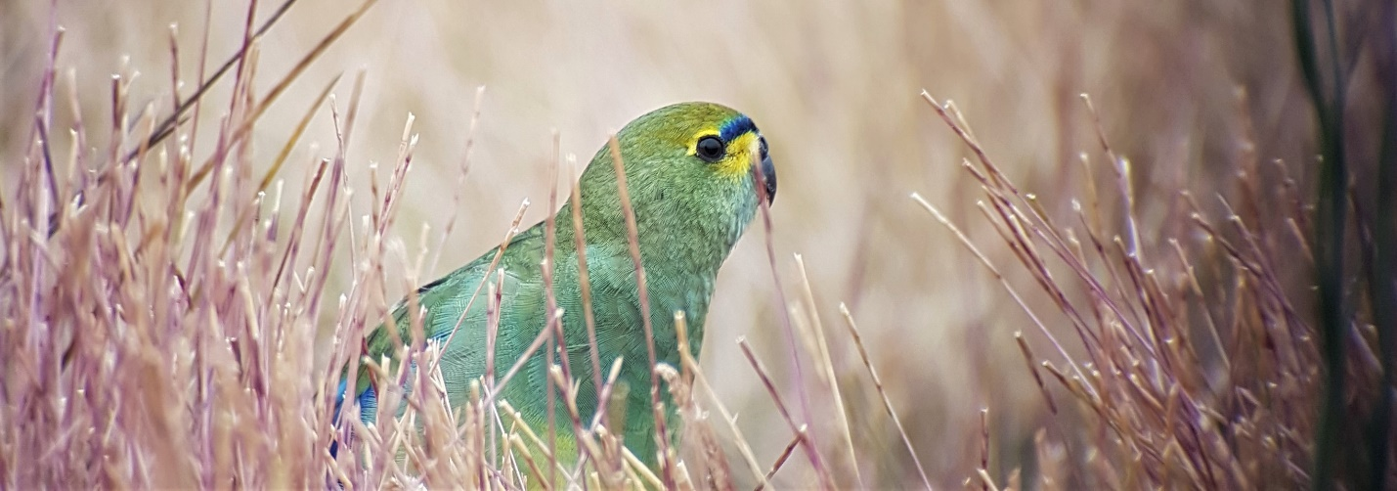
The rocky coastline will be another chance to connect with Pacific Gulls, Sooty Oystercatchers and Black-faced Cormorant, and Koala may be seen in the Manna Gum forests.

Day 12 Surf Coast, Port Phillip bay and back to Melbourne
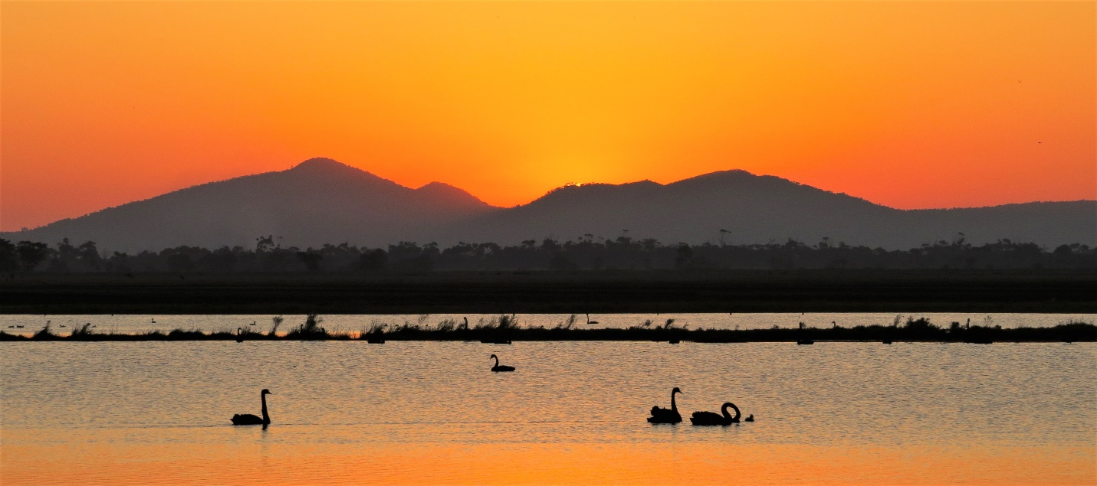

The last day of the tour will take us back along the coast to Melbourne where we will add plenty of new species to our trip list.
Whilst still on the Surf Coast we will have time this morning to check a few new sites or target birds we may have missed. A brief sea-watch might be on the cards if the winds are favourable, or perhaps a stakeout for the elusive Lewin’s Rail
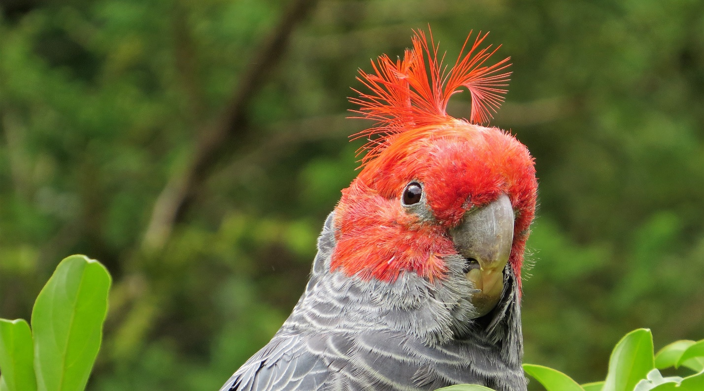
Later in the morning we will make our way back to the plains, grasslands and wetlands near Lara, Avalon and Werribee. Cape Barren Geese and Magpie Geese are now re-established here, Banded Stilts and Fairy Terns are regular in the area plus Latham’s Snipe and Purple-crowned Lorikeets, lots to look for. After lunch we will access more of the world class birding sites on Port Phillip bay.
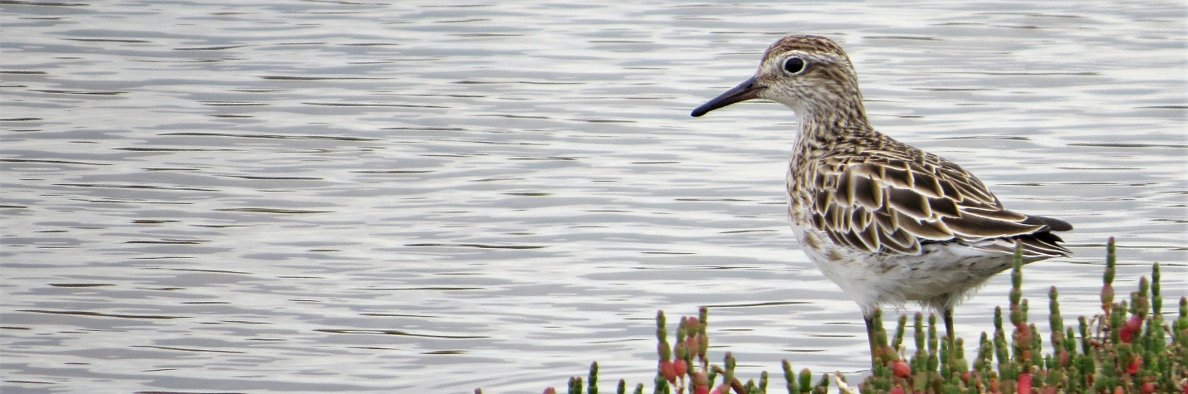
The area includes extensive areas of freshwater wetlands, coastal saltmarsh and grasslands. Migratory shorebirds are likely to be seen as well as a variety of raptors and grassland birds. Tour concludes in Melbourne between 5 and 6pm

